

Exor Corporation Limited

The Global Leader in

Infrastructure Asset Management



Network Manager

System Admin v4.5



# 

This page intentionally blank

Quality Assurance Statement

|  |  |
| --- | --- |
| Document Details | |
| **File:**  Network Manager Admin v4.5.doc | **Prepared by:**  T.C. Stewart |
| **Manual Name:**  Network Manager System Admin Guide | **Reviewed by:** |
| **Version:**  1.0 | **Approved for issue by:** |
| **Date of Issue:**  Feb 2007 | **Product Manager:**  T.C. Stewart |
| **File Name:**  Document Centre/Exor/Product Manuals/4.5.0.0 Product Manuals/4.5.0.0 completed documentation/Network Manager Admin v4.5.docx | |

|  |  |  |  |  |
| --- | --- | --- | --- | --- |
| Document Version Control | | | | |
| Revision | **Date** | **By** | **Chapter / Page** | **Description** |
| 1 | Nov 2010 | IS | All | Reviewed for 4.3 |
| 2 | May 2011 | IS | None | No Changes for v4.4 |
| 3 | Nov 2011 | IS | Various | Minor changes for v4.5 |

Contents

Quality Assurance Statement i

Process Flow 4

Product Options 5

Node Types – NM0001 10

Node Types 10

Network Types – NM0002 12

Network Types 14

Type Columns - Flexible Network Attributes 17

Type Subclass 24

Type Inclusion 26

Type Specific Module 30

Validate Network Types 31

Creating a Foreign Table Inventory Type for Datum Network Types 33

Create Datum View 36

Group Types – NM0004 37

**Sector** 1 38

**Sector** 2 38

**Sector** 3 38

Group Types 39

Group Type Properties 40

Network Type Groupings 42

Group Relations 43

Additional Data Types – NM0700 44

Network Cross Reference Rules – NM0005 48

CHAPTER

1

Introduction

This Guide is designed to aid in the setting up and maintenance of network meta-data. Careful consideration should be given to the contents of this guide when networks and network structures are being designed. Network Manager provides a very powerful and flexible network modelling package and therefore it is important that the user has a good understanding of the options available.

This Guide deals with the concepts of Administration Units, which are used to organise the networks, especially from a user security standpoint, as well as covering the actual physical network components themselves. The Guide finishes with explanations on the use of network component organisation.

This Guide will be useful to System Administrators and Experienced Users with responsibility for Network Maintenance.

This page intentionally blank

CHAPTER

2

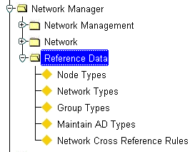Network Reference Data

Figure 1

Network Reference

Menu

This chapter describes the forms and processes that are used for defining and managing the metadata required for use with Network Manager. The forms covered in this chapter are the following:

* Product Options for Network Manager
* Node Types – NM0001
* Network Types – NM0002
* Group Types – NM0004
* Additional Data Types – NM0700
* Network Cross Reference Rules – NM0005

The form descriptions provide you with detailed information about reference data in *Network Manager by Exor*, including:

* an overall description of the form.
* a detailed explanation of each field, including available features (such as List of Values, default values and other characteristics).
* helpful information for using the form

Process Flow

Figure 3 indicates the order in which certain processes should be carried out when creating the Network Reference data for a typical Network, e.g. a Road or Rail Network. It is based on a single Datum Network Type, e.g. Classified Roads, which are grouped together to form ‘Routes’, e.g. M001. These Routes are grouped to form another group of all Routes maintained by an Organisation. Figure 2 provides a diagrammatic representation of this scenario.

###### All Routes

###### Route 1

###### Route 2

###### Route 3

###### Element 1

###### Element 2

###### Element 3

Figure 2

Create Network

Reference Data

Setting up this Network will involve the following procedures:

Figure 3

Create Network

Reference Data

Process flow

Create a Node Type

###### Node Types – NM0001

Create Network Type for ‘Route’ Group

**Network Types – NM0002**

Create Group Type for the Route Groups

**Group Types– NM0004**

Create Datum Network Type ***Network Types – NM0002***

Create a Group Type for the Group of All Routes using ***Group Types – NM0004***

Create Network Type for Group of Groups

###### Network Types – NM0002

Product Options

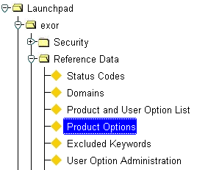

Figure 4

Product Option

Menu

Product Options allow ‘switches’ or default values to be set, which defines how certain functionality operates within the *Exor* suite of Products. The following *Network Manager* related Product Options should be set to suit your Organisational requirements. Product Options are set using *HIG9130 – Product Options.*

Several Product Options may have a User Option of the same name. The Product Option will act as the default settings. The system will check for the existence of a User Option value that will take precedence over the Product Option value. If no User Option value has been defined for the User the Product Option value will be used. Product Options, which also have an accompanying User Option, are marked with an Asterisk (*) below.

|  |  |  |  |
| --- | --- | --- | --- |
| Option Id | **Option Name** | **Sample Value** | **Remarks** |
| **AOREXTDINV** | AoR do not truncate inventory | Y | If this is 'Y', then when running Assets on a Route on a part of a linear route any continuous inventory which was truncated by virtue of the beginning or end of the specified extent will be returned with the location of that item extended beyond the selected extent |
| **AORSTRMAP** | AoR strip map by default | N | If Set to Y the Assets on Route strip Map will be displayed by default on entry into the AOR Results window. If the **User Option** of the same in present it will take precedence over the Product Option for the User |
| **ATTRLSTSEP** | Inv Attribute List Separator | , | This is the character used to separate Inv attribute values when viewed in a concatenated String. |
| **AUTOZOOM\*** | Map Synchronization | N | If this is set to ‘Y’ the Exor Web Map will automatically zoom to each record within the locator grid when the User selects a record on the Results Grid |

|  |  |  |  |
| --- | --- | --- | --- |
| Option Id | **Option Name** | **Sample Value** | **Remarks** |
| **CHECKROUTE** | Use Route Checks | N | Check network connectivity when new elements are created. Note that this should be set to N for most implementations unless directed otherwise by Exor Support Staff. |
| **DCDEXPATH** | DCD download directory | E:\UTL_FILE\ | Directory where DCD downloads are created |
| **DEFAORDPI** | Default AOR Dist Point Int | 100 | Default Assets on a Route Distance Point Interval |
| **DEFASSTYPE\*** | Default Asset Search Type | ADDR | This is the default Asset Type used in the Locator Module search module. |
| **DEFITEMTYP\*** | Default Reference Item Type | REFF | This is the Default Asset Item Type used on the Assets on a Route Module. If the User Option of the same in present it will take precedence over the Product Option for the User |
| **DISAMBIGSC** | Display Ambig Sub Class | N | Should Ambig sub class be displayed |
| **DISPWDVIS** | Discoverer Password Visible | Y | If this is set to 'Y', then when Oracle Discoverer for the Web is called the Username and password must be entered. If set to 'N' these details are passed from the current session details |
| **EDSNULLEXC** | Eng Dyn Seg - use of NULL | Y | When Y raise exceptions on use of Nulls in eng dyn seg otherwise ignore NULL values |
| **EXTRTEDATE** | Element Start Date on extend route | 3 | Default Start Date when extending a route. 1 - Leave as Null, 2 - Inherit from previous Element, 3 - Effective Date, 4 - Previous Element membership |
| **GAZ_RGT\*** | Default Gazetteer Group Type | OFFN | This option is to set the preferred Network or Group Type for the Standard Gazetteer Mode |
| **GAZMODE\*** | Gazetteer Starting Mode | NORMAL | This value is used to define which mode the gazetteer should open in, Standard or Advanced |
| **GISGRPTYPE** | GIS Road Group Type |  | This is for Backward Compatibility and is not used in Exor V3 |
| **GRPXCLOVWR** | Exclusive Group type Override | N | When value is set to 'Y' this will allow user to override the Exclusive Group Type. |
| **HISTINVLOC** | Enable Historic Asset Location | N | Set to Y to enable historic loation of assets when the network has been edited. |
| **INH_PAR_AU** | Inherit AU in reclassify | Y | If this is set to Y then upon reclassification of a route, the admin unit of the datum elements in that route inherit the AU of the parent |

|  |  |  |  |
| --- | --- | --- | --- |
| Option Id | **Option Name** | **Sample Value** | **Remarks** |
| **INVAPIPACK** | Create API pack. for inv type | N | If this is "Y", then when the inventory views are recreated for a particular inventory type, then there will be a package called nm3api_inv_xxxx created which will have API calls in as wrappers to the nm3api_inv procedures, e.g. fro an Item Type of 'BS' a package called nm3api_inv_bs will be created. |
| **INVROUTEVW** | Create inv on route views | Y | If this is "Y", then when the inventory views are recreated for a particular inventory type, then there will be a view created called v_nm_xxxx_on_route. These views are used when an Exor theme is added against a 'Route Theme shape file in SDM. |
| **INVRTETAB\*** | Default Route Tab in Inv Form | Y | If set to Y the default tab in the Inventory form will be Route. If the User Option of the same in present it will take precedence over the Product Option for the User |
| **INVVIEWSLK** | Show Offset On Inventory Views | N | If set to 'Y the Route and Route Offset details for the 'Parent' Linear Network Type defined within Network Types - NM0002 will be included in the Inventory View  Note that this Product Option should be set to 'N' under the following circumstance:   * Multiple Linear Parent Type Inclusions exist * No Linear Type Inclusions exist |
| **MAPCAPTURE** | Is MapCapture Used | N | Set this option to "Y" if the system uses MapCapture. This will enable the inventory views required for MapCapture to be generated whenever the normal inventory views are created |
| **MRGAUTYPE** | AU Type for Merge Security | TNC | This is the AU Type which is used for Merge Results Security. See the Asset Manager System Admin Guide for more details. |
| **MRGPOE** | Split Merge Results at POE | Y | A value of "Y" means that merge query results will be split at any discontinuities (POEs) on the route" |
| **MRGROUTE** | Split Merge Results by route | Y | A value of "Y" means that merge query results will be split at any change of route". Note that this should be set to N for implementations, which do not have a Linear Auto inclusion. |
| **MRGVIEWTRU** | Merge Views Include True | N | If this is set to "Y" then the TRUE distance along the OFFSET_NE_ID for the start and end of each merge chunk will be included on the merge viewss0 |
| Option Id | **Option Name** | **Sample Value** | **Remarks** |
| **MULTINVRTE** | Multiple Inventory on Network | Y | Used for placing Inventory using a Network Extent. If set to Y allow multiple routes, N - Single Route. Note that this must be set to Y if Inventory is to be located across more than 1 Datum Element and auto-inclusion into a Linear Route is not be used. |
| **NETOPENSEC** | View open/end dated sections | Y | Y = Open sections only, N = Open/End dated sections |
| **NETREASON** | Record Reason for Change | Y | On making network edits the user will be asked to record the reason for this amendment in a popup window |
| **PBIPOE** | Split PBI Results at POE | Y | A value of "Y" means that PBI query results will be split at any discontinuities (POEs) on the route" |
| **PREFLRM\*** | Preferred LRM | (Group Name) | This is the group type of the system default preferred linear referencing method; this only takes effect if you have more than one LRM. User may define their own preferred LRM using the User Preferences window (see the General User Guide) |
| **REVLEGNO** | Reverse Leg Nos on Route Rev | N | Reverse Leg Nos on node usage records when reversing a route Reverse Leg Nos on node usage records when reversing a route. "**Y**" means that the Leg Number is reversed, otherwise it will be left as is |
| **SAV_FORMAT\*** | Default Export Format | CSV or XMl | This is the default export format of data within the Locator Results Grid. |
| **SDEBATDIR** | Directory for SDE Batch files | This is the directory as seen by the server that the SDE loadevents batch file will be created in, e.g.  D:\nm3\sdm\loadevents | |
| **SDERUNLE** | Run Loadevents from server. | Y | If this is 'Y', then when the create_sde_inv_shape_table and the process_membership_changes (nm3inv_sde) procedures are executed the SDE loadevents program will be run from the server. No batch files will be executed. |
| **SDOBATSIZE** | Batch Size | 100 | Batch Size |
| **SHOWINVPK\*** | Show Primary Key in Inv Form | Y | If set to Y the primary key will always be visible on the Inventory form, if N then the PK will only be visible if it is a flexible attribute or when the form is in query mode. If the User Option of the same in present it will take precedence over the Product Option for the User |
| **SHOWRTEDIR** | Show Route Direction | N | Determines whether route direction is displayed. Note that this is used for specific Implementations of the Network Walker module and should normally be set to ‘N’ unless directed otherwise by Exor Support Staff. |
| **USEGRPSEC** | Use Group Admin Unit Security | N | Setting this option to 'N' will ignore the group members admin unit security. |
| Option Id | **Option Name** | **Sample Value** | **Remarks** |
| **USEINVXSP** | Use Inventory XSP |  | This is for Backward Compatibility and is not used in Exor V3 |
| **USEORIGHU** | Use original homo update | Y | Used in the historic asset loader, if set to Y this reverts to the original homo update code completely |
| **UTLFILEDIR** | UTL File Directory | D:\NM3 | Directory where PL/SQL will read/write flat files |
| **XMLCRENODE** | Create node from XML Datum’s | Y | Should the system automatically created nodes when Datum’s are loaded via the XML Datum’s loader. |

Node Types – NM0001

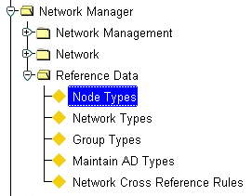Figure 5

Node Types

Menu

*Exor* has the ability to handle different types and numbers of networks. This could include, for example, Road, Rail, Ferries, Drainage, Rights of Way, Pipelines and Utility Networks. To cater for the variety of possible Network Types, different Node Types may be created. When a Network Type is defined, it will be associated with a Node Type created using this form.

A Node Type may be used for several different Network Types. For example, many Road Transportation Agencies may use one Network Type for Primary or Classified roads and another for Secondary or Local Roads. Since these 2 Network Types may ‘intersect’ and share Node positions the same Node Type may be used for both Network Types.

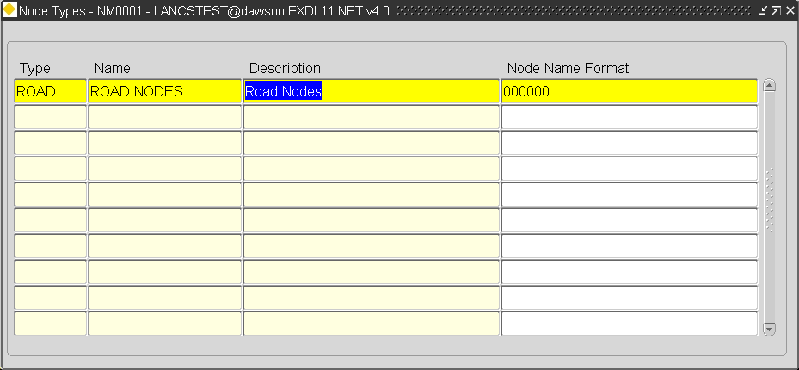Figure 6

Node Types

Node Types

When you enter this form the cursor sits in the ‘Type’ field waiting for a new Node Type to be entered or existing Types to be queried back. To query back an existing Node Type press the **[Enter Query]** button on the menu toolbar (or press F7), enter some selection criteria, then press the **[Execute Query]** button (or press F8).

Type (Required)

Enter a unique code for the Node Type. A maximum of 4 characters is allowed.

Name (Required)

Enter a Name for the Node Type. A maximum of 30 characters is allowed.

Description (Required)

Enter a description for the Node Type. A maximum of 80 characters is allowed.

Node Name Format (Optional)

When Nodes of this type are created (using ***Nodes - NM0101*** *or via the Spatial Manager*) they must have a Unique Name within the Node Type. Node Names may be automatically generated from a sequence, thus ensuring Uniqueness, by entering a format of 000000. This will generate a Node name 6 digits in length with leading zero’s, e.g. 012345. If no Node Name Format is supplied an assumption is made that the Node Names will be freehand text entries.

Formats are only applicable when the Node Name is Numeric, e.g. 123456. Non numeric Node Name formats are not allowed. If a non Numeric format is added an Error message will be displayed as shown in Figure 7 will be displayed.

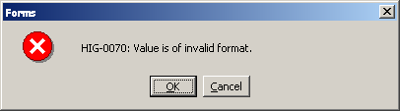Figure 7

Network Types – NM0002

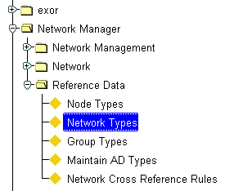

Figure 8

Network Types

Menu

***Exor*** has the ability to handle different types and numbers of Networks, or Linear Referencing Systems. This could include, for example, Road, Rail, Ferries, Drainage, Rights of Way, Pipelines, and Utility Networks. Many Road Transportation agencies may use one Network type for Primary and one Network type for secondary roads. Such users are then free to expand the system and use Network Manager to maintain other networks they require such as Rail, Drainage and electrical.

The ‘Basic’ Network Type will be flagged as being a ‘Datum’. Network Elements of this type must have a Start Node and End Node and a Length associated with them. Datum Network types will also be flagged as being ‘Linear’. This Linear Datum concept underpins the Linear Referencing System and allows for Multiple Linear Referencing methods. This datum will provide direction and connectivity to enable Network Manager to derive each of the linear referencing methods required. The user can then assign Linear Referencing Methods as views or layers on this datum. In North America, for example, this will allow a LRS to be developed that conforms to the NCHRP 20-27 model. In the UK, this allows for the storage and manipulation of National Street Gazetteer (NSG) data.

Using the flexible attribution available within the ‘Type Columns’ window can cater for different naming conventions for different Network Types. These Network Type names may be free text entries or may be derived, based on, for example, ownership and route membership or from other Network Attributes using standard Oracle formatting function calls. Unique values for Element Attributes (Data Type Number) may also be generated automatically from internal system ‘sequences’.

Each Network Type may have a property of Inclusion. This is the Inheritance of Group membership based on the association of a member with the ‘parent’ group via a common network Attribute, Unique Name, Admin Unit etc.

Multiple Type Inclusions are also permitted whereby a Network Element, or Group may be automatically included in more than one ‘parent’ Group.

When a Network Type Inclusion is applied to a Datum Network Type, any Network Elements of the Network Type will be automatically included as members of its parent group(s). If the ‘parent’ group is a Linear Group, connectivity rules will be used to derive the Elemental offsets along the Route.

Note that the ‘parent’ Network Type specified in a Type Inclusion for a Datum Network Type may be the Network Type associated with a Linear or Non Linear Group.

Network Type Inclusions may also be defined for Network Types associated with Network Groups, whereby a Group is automatically added as a member of another Network Group, thus forming a Group of Groups.

If when creating a new Network Element or Group that has a ‘parent’ Type Inclusion defined, the ‘parent’ group does not already exist, it may be created automatically by the system if the ‘Auto-Create’ checkbox on the ‘Type Inclusion’ panel is selected for the appropriate Network Type inclusion. For more information on the ‘Auto-Create’ function see page 28.

The parent network type and ‘parent/foreign’ keys used to establish the network association are defined using the ‘***Type Inclusion***’ window.

Note that if the specified 'Child Column' in a Type Inclusion is not flagged as mandatory, i.e. optional, the Element (Datum or Group) will only be auto-included as a member of the parent Group if a value is added.

Each Network Type may be sub-defined by adding a Network Type Subclass. These Subclasses may be used as part of the Network Type naming convention and in establishing the connectivity along the ‘parent’ route group. For example, a Road Network Type of ‘Classified Roads’ may have Network Type Subclasses of ‘Single’, ‘Left’ and ‘Right’. This would define whether a Network Element of this type was a Single carriageway, the Left side of a dual carriageway or the Right side of a dual carriageway. Network Type Subclasses are set up using the ‘***Type Subclass***’ window.

Network Types may be added for use when creating new Network Element Group Types which have differing naming conventions, Units of measurement or in the case of non-linear groups, have no unit of measurement e.g. a group based on a geographical region.

Network Types associated with Group Types may have a Node Type associated with them. This allows for the Start and End Nodes of a Route to be added which could later be used for schematic plans etc. If a Group Type Network Type has an associated Network Type, the Group must be created via the ***Elements - NM0105*** module. If new Datum Elements are added or existing Datum Elements end-dated and this affects either the Start or End point of the Route, the new Start or End node should be associated with the Group using the ***Elements - NM0105*** module.

Figure 9

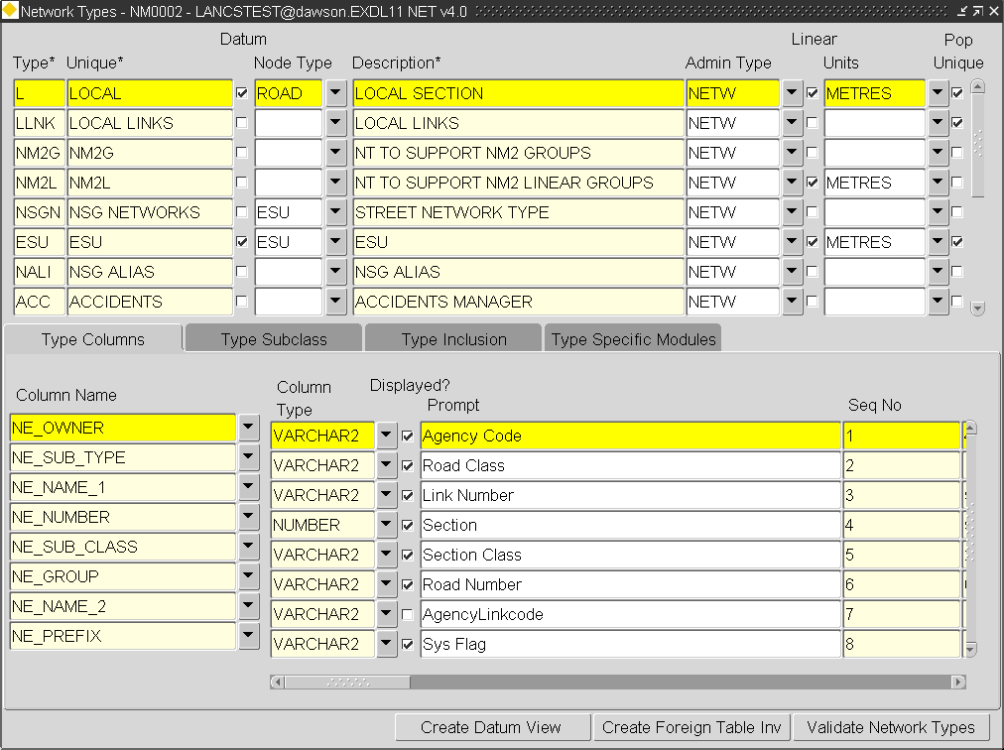Network Types

Network Types

When you enter this form the cursor sits in the ‘Type’ field waiting for a new Network Type to be entered or existing Types to be queried back. To query back an existing Network Type press the [***Enter Query***] button on the menu toolbar (or press **F7**), enter some selection criteria, then press the [***Execute Query***] button (or press **F8**).

Type (Required)

Enter a unique code for the Network Type. This code will be displayed along with the ‘Description’ in subsequent LOV’s in other forms within ***Exor***. A maximum of 4 characters is allowed.

Unique (Required)

Enter a Unique name for the Network Type. This name may be used in establishing a relationship with a ‘Parent’ Network Type using ‘***Type Inclusions***’ (🖙 Page 26). A maximum of 30 characters is allowed.

Datum (Checkbox)

Check this box if the Network Type is to be used as the ‘under-pinning’ type for the network. This type of network is generally used for creating Network Elements and will have a Start Node and End Node and an associated length. Network Elements of a type flagged as ‘Datum’ are the smallest network component within the system.

Node Type (Optional) (List)

If required, enter the type of Node to be used to define the Start and End positions of a Datum Network Element or Group of this type. Node Types are defined using ***Node Types – NM0001***.

Description (Required)

Enter a description for the Network Type. A maximum of 80 characters is allowed.

Admin Type (Required) (List)

Enter the Admin Type associated with the Network Type. This is a means of applying security to Network Types. When Network Elements or Groups associated with this Network Type are created, they must have an associated Admin Unit. The only allowable Admin Units for this Network Type, will be those Admin Units of the Admin Type entered in this field.

A User must then be granted access to the appropriate Admin Unit in order to view any Network Elements associated with the Admin Unit.

Consider an example.

The system contains 2 Admin Types, namely **ROAD** and **PIPE**, each containing the Admin Units as set out in the hierarchy below.

**Type ROAD**

###### ROAD1

###### ROAD2

###### ROAD3

**Type**

**PIPE**

###### PIPE1

###### PIPE2

###### PIPE3

A Road network and a Pipeline network exist as shown below, each element being assigned to a particular Admin Unit of the appropriate Admin Type

R1

R2

R3

P1

P2

P3

Road Network

Pipeline Network

Network Elements and associated Admin Units.

|  |  |  |  |  |
| --- | --- | --- | --- | --- |
| **Road**  **Element** | **Admin**  **Unit** |  | **Pipe**  **Element** | **Admin**  **Unit** |
| **R1** | **Road 2** |  | **P1** | **Pipe 2** |
| **R2** | **Road 2** |  | **P2** | **Pipe 3** |
| **R3** | **Road 3** |  | **P3** | **Pipe 3** |

Two Users have been set up and have been granted access to Admin Units as shown in the table below

|  |  |
| --- | --- |
| **User** | **Admin Units** |
| **User 1** | **ROAD 2** |
| **User 2** | **PIPE 3**  **ROAD 3** |

From this arrangement of Admin Types and Admin Units the following securities will be invoked:

* User 1 can access Road Elements R1 and R2 but cannot access any Pipeline Elements.
* User 2 can access Pipeline Elements P2 and P3 and also Road Element R3.

The mode of access (i.e. either Normal or Read Only) may also be defined within the ‘Admin Units’ window of the Users form.

Admin Types and Units are defined using **Admin Units - HIG1860**.

Admin Units are granted to Users using **Users – HIG1832**.

Linear (Checkbox)

Check this box if the Network Type comprises a set of connected Network Elements or is itself a ‘Datum’ Network. Linear Network Types must have an associated unit of measurement.

Units (Optional)

Enter the Unit of length used for this Network Type. The list of values is formed from the Unit Domains set up in IDH_units___conversions___overview***Units and Conversions - HIG1820***.

This is only needed for Linear Network Types.

Pop Unique (Checkbox)

Check this box if the Unique reference of the Datum Network Type or Group associated with the Network Type is to be automatically populated by derivation of flexible attributes entered in the ‘Type Columns’ window when a new Network Element or Group of this type is created. If this box is unchecked a Unique reference must be manually entered.

Figure 10

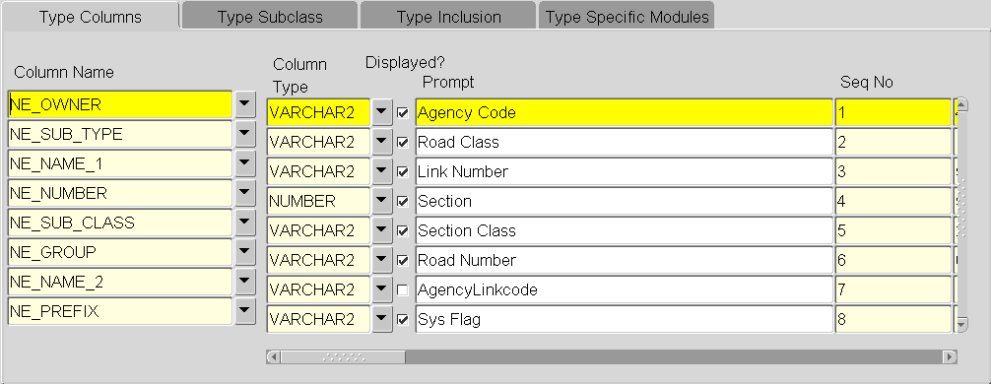Network Type Columns

Type Columns - Flexible Network Attributes

A Network Type may have a set of ‘flexible’ attributes associated with it, as is the fundamental concept of all products within the ***Exor*** set. These attributes may be used to derive different naming conventions on different Network Types or to hold ‘static’ information relating to a Network Element or Network Group.

The values for these ‘flexible’ attributes may be entered as free hand text, selected from a pre-defined set of system Domain values, generated from an internal database sequence or selected from a list of values dynamically generated from a select statement held within the ‘Query’ field.

Values for Network Attributes may also be derived from other Network Attributes using standard Oracle formatting function calls such as SUBSTR (Substring) or CONCAT (concatenate). This feature is available by entering the appropriate statement within the ‘Default’ field (see page 21). Derived values may be used within the Unique of a Network Element or within a Network Type Inclusion.

Note that it is recommended that Derived Network Attributes are not displayed as accidental population of the field will negate the derived default value.

Network Attributes are displayed on ***Elements - NM0105*** when an Element or Group of the appropriate Network Type is queried back.

The available Columns that may be used for flexible attribution are:

|  |  |
| --- | --- |
| **Column Name** | **Length** |
| **NE_OWNER** | **4** |
| **NE_NAME_1** | **80** |
| **NE_NAME_2** | **80** |
| **NE_PREFIX** | **4** |
| **NE_NUMBER** | **8** |
| **NE_SUB_TYPE** | **2** |
| **NE_GROUP** | **30** |
| **NE_SUB_CLASS** | **4** |
| **NE_NSG_REF** | **240** |
| **NE_VERSION_NO** | **240** |

If more Network Attributes are required, a ‘Primary’ Additional Data type may be created as described on page 43. This will allow an unlimited number of attributes to be defined for the Network Type.

Column Name (Required) (List)

Enter the Table Column name to be used to hold the Network Element Attribute Value.

Column Type (Required, Default) (List)

Enter the required format for the Data to be stored in this column. The valid entries, are VARCHAR2, NUMBER OR DATE. The default value is VARCHAR2.

Note: If an Attribute is validated against a Domain the 'Column Type' for the Attribute must be VARCHAR2

Column Displayed? (Checkbox)

Check this box if this attribute is to be displayed on the ***Network Elements - NM0105*** form.

Prompt (Optional)

Enter the text that the User will see when using this network attribute. A maximum of 80 characters is allowed.

Note: A maximum of 12 Characters will be displayed on the Network Elements – NM0105 form.

If a foreign table asset is to be created using this form the prompt field should not exceed 30 characters or an ORA-06502 error will be displayed.

Seq No (Required)

Enter the sequence number in which you wish this attribute to be displayed in relation to other attributes entered for the selected Network Type.

Str Length (Required)

Enter the maximum number of characters allowed for the attribute value.

Note If the attribute value is to selected from a Domain List or generated from an internal database sequence, the allowable string length must be sufficiently long to cater for the resulting value.

Mandatory (Checkbox)

Check this box if a value must be entered for this attribute.

Note that if the ‘Displayed’ checkbox is unchecked, the ‘Mandatory’ checkbox should also be unchecked.

Domain (Optional) List

If the value for this network attribute is to be validated against a System Domain, enter the Domain Name. For example, Sub Class values of ‘Left’, ‘Right’ and ‘Single’ may be held in a system Domain. This will mean that a List of Values containing only those three entries will be available for the User to select from.

System Domains are managed using Domains - HIG9120.

Note: If an Attribute is validated against a Domain the 'Column Type' for the Attribute must be VARCHAR2

Query (Optional)

A sql*plus select statement may be used to define a query to dynamically build a List of Values from which to select or validate data entry. The query statement will determine the information that is displayed to the User within the List of Values and also the data which is ‘returned’ to the calling form as the Attribute value. If required, the select statement may include reference to a single bind variable (a previously entered Attribute value).

When defining a query for use in this manner strict rules apply to the structure of the select statement.

* The Query must return 3 columns.
* The first and second columns returned are the Code and Meaning displayed within the extended LOV respectively.
* The third column returned is not displayed but is the value passed back into the calling form as the Attribute Value (if the third column is the same as the first add an Alias to the first column within the query string).
* The second column returned within the query will be displayed as the Attribute meaning within the form.
* All column names returned by the query must be unique.
* The third column must not have an alias

The example below shows a query string that dynamically builds a List of Values for the Network Type Subclass for a Network Type of ‘CSD’.

SELECT

NSC_SUB_CLASS NSC_CODE, NSC_DESCR NSC_MEANING, NSC_SUB_CLASS

FROM NM_TYPE_SUBCLASS

WHERE NSC_NW_TYPE = 'CSD'

In this example the NSC_SUB_CLASS column has been returned twice, i.e. as the ‘Code’ value and as the actual values returned to the calling form. The column used for the ‘Code’ within the LOV has been aliased to ensure it is Unique.

This query string returns an LOV as shown below

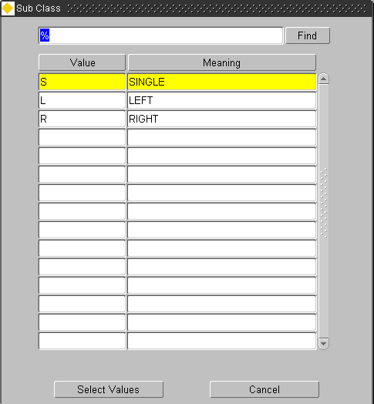

Figure 11

Network Type

Column LOV

The query may be restricted using a single bind variable that is a value of a previously specified Network attribute. These attributes may include any flexible Network Attributes or fixed columns such as Admin Unit held within the NM_ELEMENTS_ALL table. The bind variable may only be referenced once within the query string. The example below shows a query string which uses a bind variable (ne_admin_unit) to restrict the List of Values. The query is used for an Attribute named ‘Sub Area’ where the Sub Area value is a Child of the Admin Unit selected for the Network Element.

SELECT NAU_UNIT_CODE CODE,NAU_NAME,NAU_UNIT_CODE

FROM NM_ADMIN_GROUPS,NM_ADMIN_UNITS

WHERE NAG_PARENT_ADMIN_UNIT = :NE_ADMIN_UNIT

AND NAG_CHILD_ADMIN_UNIT=NAU_ADMIN_UNIT

AND NAG_DIRECT_LINK='Y'

ORDER BY NAU_UNIT_CODE

This query string returns an LOV as shown below

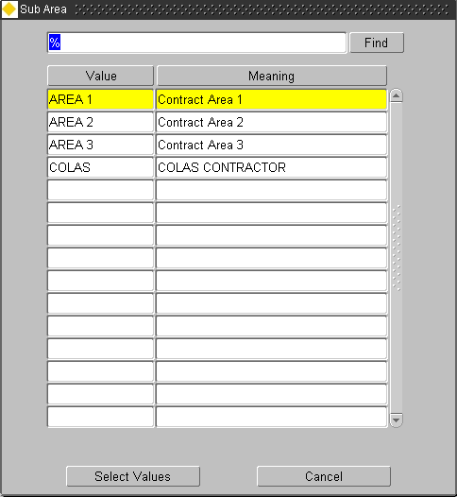Figure 12

Network Column LOV

Seq Name (Optional)

If the value for this attribute is to be generated from an internal database sequence, enter the sequence name.

Format (Optional)

If required enter a format mask for the Column. For example, defining a format of ‘000000’ would ensure that the value added for the attribute would be padded out with leading zero’s.

Note that the format mask applies to NUMBER and DATE datatypes or Varchar2 datatypes where the value entered is numeric.

Default (Optional)

A default value may be defined for a Network Attribute which may be a literal value such as ‘G’ or ‘@’ a numeric value such as 1 or 2 or may be a standard Oracle formatting function call such as SUBSTR (substring) or CONCAT (concatenate) used to derive the Attribute Value from other Network Attributes. When defining a literal value, e.g. a character or string of characters, as a default it should be enclosed in single quotes. If no User value is added for the Network Attribute the default value will be populated.

When using an oracle function call to derive the Attribute Value, the Attribute must be sequenced after all other Attributes, which it references. It is recommended that Derived Network Attributes are not displayed, i.e. the ‘Displayed’ check box is not selected, as accidental population of the field will negate the derived default value.

Several examples of using function calls to derive Attribute Values are given below.

|  |  |
| --- | --- |
| Default Value | Outcome |
| SUBSTR(:NE_NAME_1,1,3) | The first 3 characters of the value entered into the attribute using NE_NAME_1 would be returned |
| CONCAT(:NE_NAME_1,:NE_GROUP) | The values entered into the NE_NAME_1 and NE_GROUP columns will be concatenated |

String Start (Optional)

If only ‘part’ of the Value entered for this attribute is to be used in the naming convention for the Network Element, enter the String start position. For example, if the attribute value was ‘ABCDEFG’ and only the ‘CDE’ part of the String was required, the Start String position would be entered as ‘3’.

String End (Optional)

If only ‘part’ of the Value entered for this attribute is to be used in the naming convention for the Network Element, enter the String End position. For example, if the attribute value was ‘ABCDEFG’ and only the ‘CDE’ part of the String was required, the End String position would be entered as ‘5’.

Separator (Optional)

If this attribute is to be used as a component part of the Unique Element Reference, a digit may be used to separate the component parts of the Unique reference. For example, if the Unique Reference was composed of columns NE_GROUP, NE_NUMBER AND NE_SUB_CLASS and separators were specified as ‘**/**’ for column NE_GROUP and ‘**-**‘ for NE_NUMBER, the resulting Unique Reference may look like **H001/1-S**.

Unique Sequence (Optional)

If this attribute is to be used as a component part of the Unique Element Reference, enter the sequence number that this attribute will assume in the Unique naming convention.

Unique Format (Optional)

Attributes used as a component part of the Unique Element Reference may have their values formatted when used within the Unique using standard Oracle formatting function calls. This allows features such as right padding with spaces to be incorporated within the Unique of a Network Element. For example, an Attribute is validated against a System Domain with allowable values of ‘I’ – Interstate and ‘CN’ – County. This attribute (ne_sub_type) is used in the derivation of the Unique. In order to have a Unique with a constant length the Attribute value within the Unique must always be 2 characters in length. However, if a value of ‘I’ – Interstate is selected this must be padded with a space character. Defining the following statement for the attribute will allow for this

RPAD(:NE_SUB_TYPE,2)

Inherit (Checkbox)

Check this box if a new Network Element of the Network Type selected, created as a result of a Network Operation e.g. Split, will ‘Inherit’ the properties of the selected Column. For example, columns NE_GROUP, NE_SUBCLASS and NE_OWNER may be used in the naming convention of a Network Type and each is flagged as ‘Inheritable’. If a Network Element of this Network Type was ‘Split’, the resulting Network Elements would ‘Inherit’ their values for columns NE_GROUP, NE_SUBCLASS and NE_OWNER from the ‘original’ Network Element.

Notes

If a Datum Network Type is not using a Network Type Subclass as a carriageway identifier (see page 24) the NE_SUB_CLASS attribute MUST still be defined as a Flexible Attribute. The ‘Display’ and ‘Mandatory’ flags may be left unchecked to make the attribute ‘transparent’ to the User. A default value of ‘S’ should be defined in the ‘Default’ field and the ‘Inherit’ flag MUST be selected.

A Type Subclass of ‘S’ must also be defined in the Type Subclass panel. No description is needed.

If a Network Type column is used as 'Child Auto-Inclusion' the column value is non updateable in the Elements - NM0105 module.

Figure 13

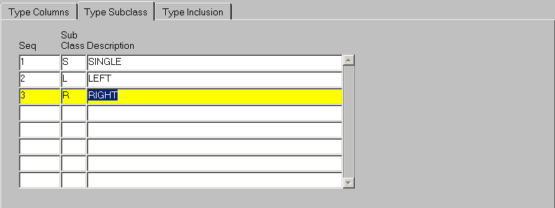Type Subclass

Type Subclass

This window is used to define Network Type Subclass’s for the selected Network Type. Network Type Subclass’s are commonly used as Indicators to denote the ‘type’ of a Network Element e.g. Left, Right or Single. The Network Type Subclass may also be incorporated as part of the Element reference number to ensure uniqueness.

The Network Type Subclass may be an important indicator when establishing and using a Route and Offset linear referencing method. When calculating the length of a linear Route, and hence Offsets along the Route, the system must be able to identify the appropriate Elements to base it’s calculations on. For example, the length of a Road Network Type Route may be based on the total length of the Single Carriageway Elements plus the total of the Left Carriageway Elements where a Dual Carriageway or Divided highway exists. The Network Type Subclass would allow this distinction to be made.

When referencing events by a Route and Offset method, the position referenced may be ambiguous. For example, an Offset of 2.3 Kilometres on Route S234 may be ambiguous if this reference is locating a point on a Dual Carriageway or Divided Highway. By using Network Type Subclass’s it is possible to Uniquely identify the reference, i.e. either the Left side or the Right side.

Each Network Type and Network Type Subclass combination may have a unique set of XSP values. These are defined using ***XSP and Reversal Rules- NM0305***.

When you enter this window any Type Subclass’s already entered for the selected Network Type will be displayed. To add another Network Type Subclass press the [***Create Record***] button on the menu toolbar (or press F6).

Seq (Required)

Enter a sequence number to order the display of the Network Type Subclasses within the selected Network Type.

The Sequence number is also used to define the precedence of how the Route Offset or SLK/Offset is calculated. Consider the example in

Figure 14

Subclass precedence

|  |  |  |
| --- | --- | --- |
| **Sequence** | **Subclass** | **Description** |
| **1** | **S** | **Single** |
| **2** | **L** | **Left** |
| **3** | **R** | **Right** |

The table in displays the Network Type Subclass’s for a Road Network Type. shows the preferential order taken to calculate the Route Offset or SLK when a new Network Element is added to a route.

When an Element whose type is given along the top row of the table is appended to an Element of the type given in the left column of the table, the resultant O will allow the calculation of the SLK. The X indicates that although the SLK will be derived a warning message will be displayed.

Figure 15

Subclass precedence

|  |  |  |  |
| --- | --- | --- | --- |
|  | **Single** | **Left** | **Right** |
| Single | **O** | **O** | **O** |
| **Left** | **O** | **O** | **O** |
| **Right** | **X** | **X** | **O** |

Subclass (Required)

Enter a code for the Network Type Subclass. A maximum of 4 characters is allowed.

Description (Required)

Enter a description for the Network Type Subclass. A maximum of 80 characters is allowed.

Note on Sub Class

If a Datum Network Type is not using a Network Type Subclass as a carriageway identifier (see page 24) the NE_SUB_CLASS attribute MUST still be defined as a Flexible Attribute. The ‘Display’ and ‘Mandatory’ flags may be left unchecked to make the attribute ‘transparent’ to the User. A default value of ‘S’ should be defined in the ‘Default’ field and the ‘Inherit’ flag MUST be selected.

A Type Subclass of ‘S’ must also be defined in the Type Subclass panel. No description is needed.

Figure 16

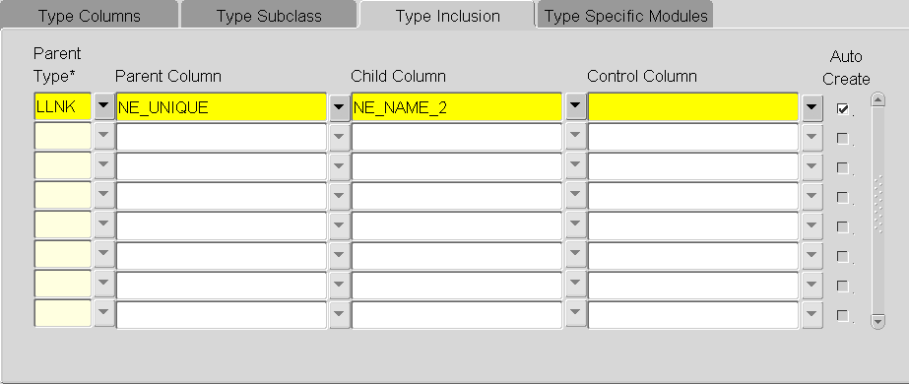Type Inclusion

Type Inclusion

Each Network Type may have a property of Inclusion. This is the Inheritance of Group membership based on the association of a member with the ‘parent’ group via a common network Attribute, Unique Name, Admin Unit etc.

Multiple Type Inclusions are also permitted whereby a Network Element, or Group may be automatically included in more than one ‘parent’ Group.

When a Network Type Inclusion is applied to a Datum Network Type, any Network Elements of the Network Type will be automatically included as members of its parent group(s). If the ‘parent’ group is a Linear Group, connectivity rules will be used to derive the Elemental offsets or displacements along the Route. **Note that the ‘parent’ Network Type specified in a Type Inclusion for a Datum Network Type may be the Network Type associated with a NON-Linear group.**

Network Type Inclusions may also be defined for Network Types associated with Network Groups, whereby a Group is automatically added as a member of another Network Group, thus forming a Group of Groups.

If when creating a new Network Element or Group which has a ‘parent’ Type Inclusion defined, the ‘parent’ group does not already exist, it may be created automatically by the system if the ‘Auto-Create’ checkbox is selected for the appropriate Network Type inclusion. .

The Control Column field is used to ensure the uniqueness of the Network Element reference within the group.

Consider 2 examples.

Example 1

A Datum Network Type of ‘**DOT**’ has a prescribed naming convention, which uses the following network type columns:

|  |  |  |
| --- | --- | --- |
| **Table Column** | **Attribute Name** | **Example value** |
| **NE_GROUP** | **Group** | **H001** |
| **NE_NUMBER** | **Number** | **1** |
| **NE_SUBCLASS** | **Subclass** | **S** |

A Network Element of this type may have the Unique Reference **H001/1-S**. These ‘**DOT**’ Network Elements have an automatic inclusion into their ‘parent’ Route group.

The Datum Network Type has the following Type inclusion defined.

|  |  |  |  |
| --- | --- | --- | --- |
| **Parent Type** | **Parent Column** | **Child Column** | **Control Column** |
| **CRT** | **NE_UNIQUE** | **NE_GROUP** | **NE_NUMBER** |

The parent Route is created using Network Type ‘**CRT**’ and the unique Route reference is held in table column **NE_UNIQUE,** e.g. **H001**.

When a new Datum Network Element of type ‘**DOT**’ is created, the **NE_GROUP** attribute will be entered by the User. The **NE_GROUP** of a Network Element of type ‘**DOT**’ equates to the Unique reference (**NE_UNIQUE**) of it’s parent route (Network Type ‘**CRT**’). Defining the **NE_UNIQUE** and **NE_GROUP** columns in the ‘Parent Column’ and ‘Child Column’ fields respectively for Network Type ‘DOT’ will result in the Network Element being auto included as a member of it’s parent Route group.

The Control Column (**NE_NUMBER**) will ensure that the number attribute is unique and will start at ‘1’ for each new Group.

Example 2

An Organisation is sub-divided into 6 Regions, each with a different Admin Unit. When a Network Element is created it is given the Admin Unit of the Region it is within. A Network Group exists for each of the Regions, each with it’s given Admin Unit.

The Datum Network Type has the following Type inclusion defined.

|  |  |  |  |
| --- | --- | --- | --- |
| **Parent Type** | **Parent Column** | **Child Column** | Control Column |
| **REGO** | **NE_ADMIN_UNIT** | **NE_ADMIN_UNIT** |  |

When a new Element is created it will automatically be included as a member of the appropriate Regional Group by virtue of it’s Admin Unit number.

Parent Type (Required) List

Enter the Parent Network Type for the Selected Type of Network.

Parent Column (Required)

Enter the table column used to store the Unique Reference of the parent Group, e.g. NE_UNIQUE.

Table 1 displays the available Columns.

Child Column (Required)

Enter the table column used to store the ‘foreign’ key of the child network type, e.g. NE_GROUP.

Table 1 displays the available Columns.

Table 1

|  |  |
| --- | --- |
| **Column** | **Description** |
| NE_ID | The unique Internal Id of the Element/Group |
| NE_UNIQUE | The User defined Unique of the Element/Group |
| NE_TYPE | The Type of Network Element (G=Group,S=Element) |
| NE_NT_TYPE | The Network Type Code |
| NE_DESCR | The Element/Group description |
| NE_LENGTH | The Length of the Datum Element |
| NE_ADMIN_UNIT | The Admin Unit of the Group/Element |
| NE_DATE_CREATED | The date on which the Group/Element was created |
| NE_DATE_MODIFIED | The date on which the Group/Element was modified by a User |
| NE_MODIFIED_BY | The Username of the User who modified the Group/Element |
| NE_CREATED_BY | The Username of the User who created the Group/Element |
| NE_START_DATE | The User defined start date for the Group/Element. |
| NE_END_DATE | The End Date of the Group/Element if it has been closed. |
| NE_GTY_GROUP_TYPE | The Group Type code if the NE_TYPE is ‘G’ |
| NE_OWNER | User definable Flexible Attribute |
| NE_NAME_1 | User definable Flexible Attribute |
| NE_NAME_2 | User definable Flexible Attribute |
| NE_PREFIX | User definable Flexible Attribute |
| NE_NUMBER | User definable Flexible Attribute |
| NE_SUB_TYPE | User definable Flexible Attribute |
| NE_GROUP | User definable Flexible Attribute |
| NE_NO_START | Start Node of the Datum Element |
| NE_NO_END | End Node of the Datum Element |
| NE_SUB_CLASS | The Subclass of a Datum Element ** |
| NE_NSG_REF | User definable Flexible Attribute |
| NE_VERSION_NO | User definable Flexible Attribute |

** see note on page 25.

Control Column (Optional)

Enter the table column used to ensure uniqueness of the group membership reference numbers, e.g. NE_NUMBER. If a table column is added for this field, the Number generated will be sequenced relative to its ‘parent’, i.e. for each new ‘parent’ Group the count will start at ‘1’.

Auto Create (Optional)

If the ‘parent’ group does not already exist, it may be created automatically by the system if the ‘Auto-Create’ checkbox is selected.

Note that if the Parent Network Type is not flagged as Pop-Unique the Parent Column must be specified as NE_UNIQUE.

When creating an Element of this Network Type via the ***Elements – NM0105*** module a List of Values will be provided for the Attribute that has been defined as the Child Column in the Network Type Inclusion. If the parent Group does not yet exist the List of Values may be cancelled and the appropriate value added for the Attribute. The value entered will follow and formatting rules specified in the ‘Format’ field of the Type Columns panel. When the Element is saved the Parent Group will be created with the Group Unique being derived from the value entered for the ‘Child’ Attribute.

If the Network Type associated with the 'parent' Group type has a Node Type associated with it, the Group Type cannot be flagged as 'Auto-Create'. The 'Validate Network Type' button (see page 28) should be used to detect any invalid Network Metadata.

Note that if the specified 'Child Column' in a Type Inclusion is not flagged as mandatory, i.e. optional, the Element (Datum or Group) will only be auto-included as a member of the parent Group if a value is added.

Figure 17

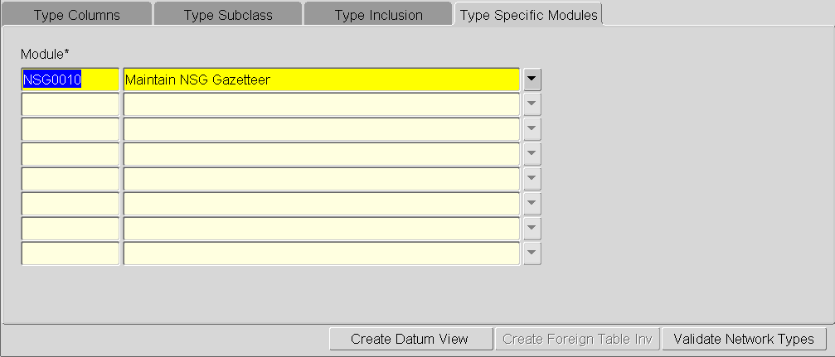

Type Specific Module

The ‘Type Specific Modules Tab’ is used to define which Network modules, Elements of the selected Network Type may be viewed within. If a module is defined for a Network Type, Elements of that Type cannot be viewed with the following Forms:

* NM0105 – Elements
* NM0110 – Groups of Sections
* NM0115 - Groups of Groups

This feature is currently used within Street Gazetteer Manager to prevent Streets (Network Type NSGN) being maintained within the modules mentioned above by defining the NSG0010 module as the specific module used to manage these Network Types.

Note that NSG0010 must not be removed as a Type Specific Module for Network Type NSGN.

* Figure 18

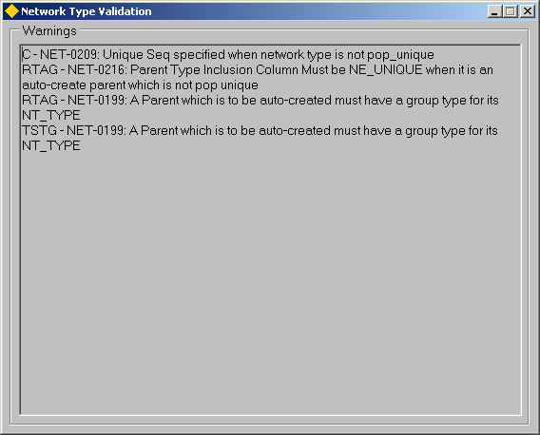

Validate Network Types

Figure

The metadata defined for Network Types may be checked by pressing the **[Validate Network Type]** button on the form. This will check the Columns specified for attributes are valid, Unique Seq values are valid, Type Inclusion Properties are valid etc.

If any errors are detected these must be corrected before data is entered using any invalid Network Types. The Error number is preceded with the ‘Invalid’ Network Type, e.g. ‘**RTAG - NET 199 A Parent which is to be auto-created must have a group type for its NT_TYPE’** where RTAG is the invalid Network Type.

displays a full list of Network Type Validation error Messages.

Table 2

|  |  |
| --- | --- |
| **Error Code** | **Meaning** |
| NET 198 | Sub Class not valid on Network Type |
| NET 199 | A Parent which is to be auto-created must have a group type for its NT_TYPE |
| NET 200 | A Parent which is to be auto-created may only have a single group type for its NT_TYPE |
| NET 201 | Invalid ne_type supplied |
| NET 202 | Network Type not supplied |
| NET 203 | Invalid Network Type supplied |
| NET 204 | Element Description not supplied |
| NET 205 | Admin Unit must be supplied |
| NET 206 | Start Date must be supplied |
| NET 207 | Datum Network Types must have a node type associated |
| NET 208 | Unique Seq used more than once |
| NET 209 | Unique Seq specified when network type is not pop_unique |
| NET 210 | No Unique Seq specified when network type is pop_unique |
| NET 211 | Column is not a valid NM_ELEMENTS_ALL column |
| NET 212 | Column is defined as a child type-inclusion column more than once |
| NET 213 | Column is defined as a code control both as a child inclusion and as a parent inclusion |
| NET 214 | Column is defined as a parent type-inclusion column more than once |
| NET 215 | Column is defined as a code control column more than once |
| NET 216 | Parent Type Inclusion Column Must be NE_UNIQUE when it is an auto-create parent which is not pop unique |
| NET 217 | Column cannot be mandatory when an auto-create type inclusion parent |
| NET 218 | Column forms part of unique sequence, but is not parent type inclusion column |
| NET 257 | Cannot auto-create parent where parent type has an associated Node Type |

Creating a Foreign Table Inventory Type for Datum Network Types

Inventory Types may be defined to represent Datum Network Elements using the Foreign Table functionality available via module ***NM0410 – Inventory Metamodel***.

Figure



This allows flexible attributes and other ‘fixed’ information relating to Datum Network Elements to be used when defining queries such as Parameter Based Inquiries (***NM7040***) and Merge Queries (***NM7050***).

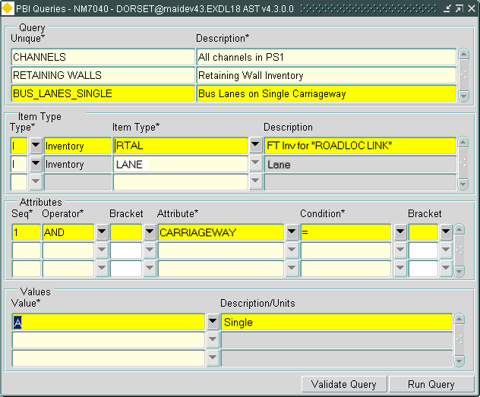Figure 21

shows an example of a PBI query definition where the Foreign Table Inventory type for a Datum Network Type is being used to restrict the query to only those parts of the selected Region of Interest where the Carriageway Type is ‘**A**’ – single (CARRIAGEWAY is an attribute of the Datum Network Type).

Foreign Table Inventory definitions for any Datum Network Types defined in ***NM0002 – Network Types*** may be created by pressing the **[Create Foreign Table Inv]** button on in ***Network Types - NM0002*** (Network Manager Admin Guide).

This will create a ‘Continuous’ Inventory Type for the selected Datum Network Type of category '**X**' - Generated Exclusive Inventory Type. The Inventory Type Name will be defaulted to the Network Type but this may be amended using the 'Inventory Type' field in the 'Create Foreign Table Inv' () dialogue. The Inventory Type description will be in the format of : **FT Inv for "*Datum Network Type Description*" e.g. FT Inv for “Classified Roads”**. This Inventory Type description may be amended if required.

A foreign table join will be created to a database view. The naming convention of the View name is as follows:

V_NM_<Item code>

for example **V_NM_CLAS**

where ‘CLAS’ is the Inventory Type code for the Datum Network Inventory Type.

The remainder of the Foreign Table join definition is as follows:

Primary Key Column NE_FT_PK_COL

LR NE Column Name NE_ID

LR Start Chain NE_BEGIN_MP

LR End Chain NE_LENGTH

An Inventory Attribute will be created for each of the flexible network attributes defined in the ‘*Type Columns*’ field for the Datum Network Type in ***NM0002 – Network Types***, as well as Attributes for ‘fixed’ attributes such as Length, Admin Unit and Description. Any unwanted Inventory Attributes may be ‘End Dated’ by selecting the required Attribute and pressing the [**Delete**] button on the menu toolbar.

displays the Inventory Attributes that will be created:

Table 3

|  |  |  |
| --- | --- | --- |
| **Attribute Name** | **Screen Text** | **View Column Name** |
| NE_ID | Id | NE_ID |
| NE_FT_PK_COL | Ft Pk Col | NE_FT_PK_COL |
| NE_UNIQUE | Unique | NE_UNIQUE |
| NE_BEGIN_MP | Begin Mp | NE_BEGIN_MP |
| NE_LENGTH | Length | NE_LENGTH |
| START_NODE_ID | Start Node Id | START_NODE_ID |
| END_NODE_ID | End Node Id | END_NODE_ID |
| NE_DESCR | Descr | NE_DESCR |
| NE_START_DATE | Start Date | NE_START_DATE |
| NE_ADMIN_UNIT | Admin Unit | NE_ADMIN_UNIT |
| ADMIN_UNIT_CODE | Admin Unit Code | ADMIN_UNIT_CODE |
| …Attribute 1… | …Attribute 1… | Attribute 1… |
| …Attribute 2… | …Attribute 2… | Attribute 2… |
| …etc… |  |  |

If any of the Network Attributes defined in the ‘*Type Columns*’ field for the Datum Network Type in ***NM0002 – Network Types*** are validated against a System Domain (maintained using ***HIG9120 – Domains***) an Inventory Domain will be created and the Domain associated with the appropriate Attribute allowing a List of Allowable value to be displayed for the Attribute when defining a query such as PBI or Merge.

The Inventory Domain created will derive its name from the name of the System Domain. If an Inventory Domain of this name already exists the Inventory Domain Title will checked against the System Domain Title. If the Domain Titles are also the same a new Inventory Domain will not be created and the existing Inventory Domain will be associated with the Inventory Attribute.

If however, the Inventory Domain and System Domain names are the same but the Inventory and System Domain Titles are different a new Inventory Domain will be created using the following naming convention:

<Datum Network Type Name_HIG_DOMAIN Name>

for example CLAS_CARRIAGEWAY_TYPE

where ‘CLAS’ is the Datum Network Type and ‘CARRIAGEWAY_TYPE’ is the System Domain Name.

Note that if additional lookup values are added to the System Domain these must also be added to the corresponding Inventory Domain.

An appropriate User Role must be defined in Order for an Exor User to have access to the Inventory Type.

When the button is pressed a dialogue will be displayed as in .

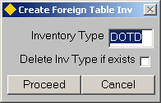

Figure 22

Inventory Type (Required) (List)

The Inventory Type Code will default to the Network Type Code. This may be changed if required. **A maximum of 4 characters is allowed.**

Delete Inv Type if exists (Checkbox)

If this flag is selected and an Inventory Item type of the Code entered in the 'Inventory Type' field already exists and also of Category '**X**' - Generated Exclusive Inventory Type , the existing Inventory Type will be deleted.

To create the Foreign Table Inventory Type press the **[Proceed]** button or **[Cancel]** to close the dialogue. If the **[Proceed]** button is pressed a message will be displayed informing the User that the Foreign Table Inventory Type will be created. To carry out the operation press the **[OK]** button.

Create Datum View

Figure 23

If a ‘Primary’ Additional Data Item Type (see page 43) has been Linked to a Datum Network Type a ‘Datum View’ should be created by pressing the [Create Datum View] button on the Form. The resultant view will join the Network Attributes and the Additional Data Attributes together and may be used as the basis of a GIS Theme.

Group Types – NM0004

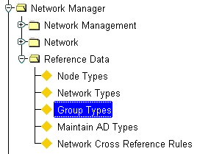Figure 24

Group Types Menu

The Group Types Form is used to define the Network Groups Types and Group Relationships used within your Organisation. Network Groups allow a collection of Network Elements to be grouped together or ‘categorized’, allowing different parts of the Network to be viewed and analysed for different functional reasons.

For example, a Group Type would be created to represent Network Routes. These Route Groups would comprise of all the Network Elements which when ‘chained’ together would form the Network Route. Group types such as ‘Route’ groups would be flagged as being ‘Linear’. A linear group uses the connectivity of its member Elements (i.e. the End Node of one Element is the Start Node of the adjoining Element) to derive Offsets or SLK values along the Route.

Points of physical discontinuity along a Route, for example, at a staggered junction or Intersection, may be overcome to allow ‘logical’ connectivity along the Route by the addition of Distance Breaks

The system will also cater for discontinuities caused by irregular measured distances of member Network Elements by created a Point of Equation at the discontinuous Node Point. A Point of Equation may be either a Gap or an overlap. For more information on Points of Equation (POE) refer to the Network Manager User Guide.

Group Types may also be non-linear, such as Groups representing a geographical region or area of interest based on Inventory Items with similar attribution.

Group Type may also be defined as allowing portions of Network Elements to be included. These group types are known as partial groups. Partial Groups may be created as a result of a query of Inventory Items with similar attribution.

Careful planning of Group Types and Group Type hierarchies will allow reporting on a Network at any Level, from District or County level right through the hierarchy, down to individual Routes or parts of Routes between Intersections or Junctions for example.

shows an example of the various levels within a group hierarchy. Examples of the Group Type Names are displayed in Brackets.

Figure 25

**Example of Gazetteer Group Hierarchy**

Group Type Hierarchies

All

Road Classes

(Top)

All

Section Offices by Sector

(Top)

All

Section Offices by Section

(Top)

All

Routes

(Top)

All

Councils

(Top)

All

Local Roads

(Top)

All

Post Roads

(Top)

All

Towns

(Top)

Section Offices

(Seco)

Town

Name

(Town)

Road Class

(Clas)

Sectors

(Sec)

All

Section Offices

(Secn)

Rout

(Rout)

Council

(Coun)

Local Road

Name

(Locn)

Postal Road Name

(Road)

Datum Network

From this example the structure of the ‘All Section Offices by Sector’ hierarchy may be depicted as shown in .

**All Section** Offices

Figure 26

###### Section Office 1

###### Section Office 3

###### Section Office 2

**Sector** 1

**Sector** 2

**Sector** 3

**Element** 1

**Element** 2

**Element** 3

**Element** 4

This hierarchy of Network Groupings would allow reporting on the Entire Network (All Section Offices), Individual Section Office Area (Section Office 1 etc), Individual Sectors within a Section Office Area (Sector 1,2 etc) or the Individual Network Elements, which are members of the Sector Grouping.

Associating a Network Element to the first level of groups is carried out using Groups of Elements (🖙 Network Manager User Guide), or through the Group Creation function in Create Network Extent (🖙Network Manager User Guide).

Additional Attributes may be defined for a Group Type using the ***NM0700 – Additional Data Types*** module (page 43). There are two distinct types of Additional Data. ‘Primary’ Additional Data is treated as extra User defined Attributes of the Group whereas non-primary AD may be used to hold information that relates to the Group, such as Traffic Sensitivity or Reinstatement Designations.

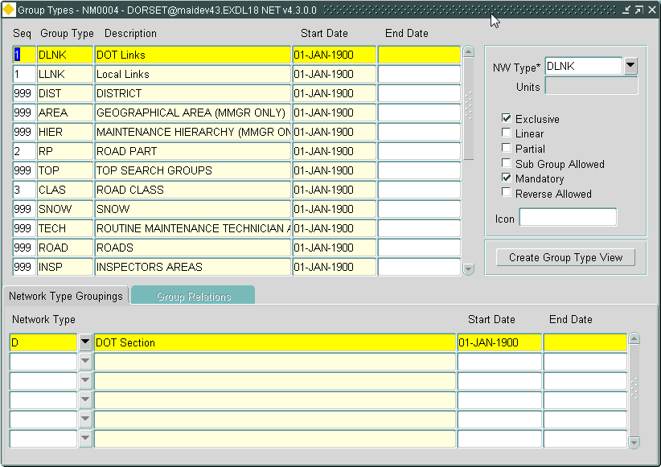Figure 27

Group Types

Group Types

When you enter this window the cursor sits in the ‘Seq’ field waiting for a new Group Type to be entered or existing Group Types to be queried back. To query back an existing Network Type press the [***Enter Query***] button on the menu toolbar (or press **F7**), enter some selection criteria, then press the [***Execute Query***] button (or press **F8**).

Seq (Required)

Enter a Sequence Number to order the Group Type relative to other Types.

Group Type (Required)

Enter a Code for the Group Type. A maximum of 4 characters is allowed.

Description (Optional)

Enter a description of the Group Type you have just entered. This description will be used in the Gazetteer. A maximum of 40 characters is allowed.

Start Date (Required)

Enter the date from which Groups of this Type may be created.

End Date (Optional)

Enter the date to which Groups of this Type may be created.

Group Type Properties

NW Type (Required) List

Enter the Network Type from which Groups of this type will derive their characteristics. This will affect such properties as the Group naming convention and units of measurement used for the Group. For more information on Network Types refer to page 12.

Units (Display Only)

The unit of measurement defined for the selected Network Type will be displayed.

Exclusive (Checkbox)

Check this box if a Network Element, or any part of the Element, may only be a member of one Group of the selected Type. For example, if a Network Element, or any part of it, may only be a member of one Route Group the exclusivity flag should be checked.

Linear (Checkbox)

Check this box if Groups of this type are linear, i.e. the member Elements are connected at Node Points or by using Distance Breaks. Route Offsets or SLK values will be derived for Groups of this type. If a Group Type is flagged as ‘Linear’, the Group must be at the ‘first level’ in the hierarchy, i.e. it is a Group of Elements and cannot have Sub Groups as members.

Partial (Checkbox)

Check this box if Groups of this type may contain ‘Partial’ Network Elements, i.e. the entire measured length of an Element is not included in the Group membership. This may be typical of Groups created as a result of a PBI query (🖙 Asset Manager User Guide) or a Partial Network Extent. If a Group Type is flagged as ‘Partial’, the Group must be at the ‘first level’ in the hierarchy, i.e. it is a Group of Elements and cannot have Sub Groups as members.

Sub Group Allowed (Checkbox)

Check this box if Groups of this type may have other groups as members, i.e. the Group is a Group of Groups. An example can be seen in Figure 25, where the ‘Section Office’ group type SECN, has sub groups of type SECR as it’s members. The Group Types which may be Sub Groups of the selected Group Type are defined in the Group Relations window of this form .

Mandatory (Checkbox)

Check this box if a Network Element of the Network Type specified in the Network Type Groupings window must belong to a Group of this Type. For example, if Elements of a Datum Network Type of ‘Classified Roads’ must belong to their ‘parent’ Route Group, the Route Group Type would be flagged as Mandatory.

Reverse Allowed (Checkbox)

Check this box if a Group of this type may have member Elements which do not share the same cardinality. This may occur for example, on a Route used for Inspection Purposes. Consider the example below where the 2 Elements shown are both members of the same Inspection Route.

Route 99

Element 13

Route 66

Element 5

Cardinal Direction of Elements

Direction of Inspection Route

Icon (Optional) (Browse)

An icon file may be associated to represent this Group Type and will be displayed in the ‘Hierarchy’ area of the Gazetteer/Navigator Form. To browse the system for the appropriate icon file press the ‘Open Folder’ button adjacent to the field. This will call a Standard Windows ‘Open’ dialog box as shown in Figure 28

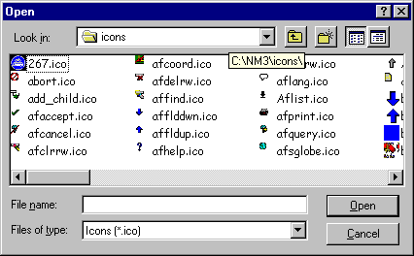Figure 28

‘Open’ dialog box

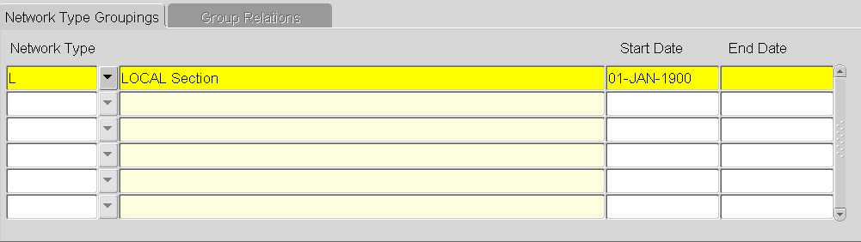Figure 29

Network Type

Groupings

Network Type Groupings

This window is used to specify the Network Types, which may be members of the selected Group Type. This window is only available for Groups that have not had the ‘Sub Group Allowed’ flag checked.

Network Type (Required) (List)

Enter the Network Type that may be a member of the selected Group Type.

Start Date (Required)

Enter the date from which Elements of this Network Type may be added as members of the selected Group Type.

End Date (Optional)

Enter the date to which Elements of this Network Type may be added as members of the selected Group Type.

Figure 30

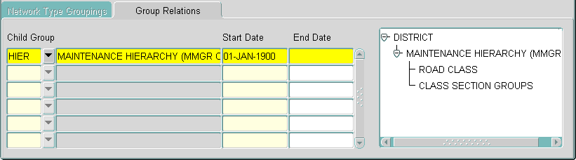Group Relations

Group Relations

This window is used to define the Subgroups that a Group of the selected type may have as members. This window will only be available for those Group Types that have the ‘Sub Group Allowed’ flag checked. Only Group Types entered here will be displayed in the List of Value for Sub Groups when a Group hierarchy is being built in ***Groups of Groups - NM0115*** for the selected Group Type.

Child Group (Required) List

Enter the Group Type, selectable as a Sub Group of the selected Group Type.

Start Date (Required)

Enter the date from which Groups of this Type may be added as members of Groups of the ‘Parent’ type selected.

End Date (Optional)

Enter the date to which Groups of this Type may be added as members of Groups of the ‘Parent’ type selected.

A pictorial representation of the Group Hierarchy will be displayed in the adjacent window. To expand the hierarchy one level, click the + symbol adjacent to the Group Type required. To collapse the hierarchy click the – symbol.

Additional Data Types – NM0700

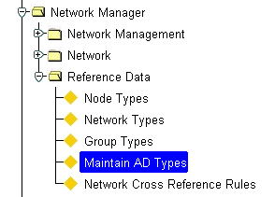

Figure 31

Additional Data

Types Menu

Base Datum Network Types or Group Types may have Additional Data associated with them in order to provide extra Network Attributes and/or to ‘tag’ relevant data to a Group or Base Datum. This mechanism is used to provide the additional attributes required on RMMS Maintenance Sections within the UK and Associated Street Data (ASD), e.g. Reinstatement Category or Traffic Sensitivity on Level 1 Streets within the National Street Gazetteer. Additional Data is held internally as Asset Data and therefore an appropriate Asset Type must be defined with the relevant attributes using the ***Inventory Metamodel – NM0410*** module (refer to the Asset Manager System Admin Guide for details). When defining the Associated Data Asset Type(s) the following rules must be observed

* The Asset Type Category must be ***‘G’ – Additional Data***
* The Admin Type of the Asset Type must be the same as the Admin Type of the Network Type / Group Type to which it will be associated
* A User must have NORMAL Role based and Admin Unit based access to the Asset Type in order to create a Network Element with Associated Data

Additional Data falls into 1 of 2 categories, namely ***‘Primary’*** and ***‘Non-Primary’***. Primary AD is treated as additional attributes of the Network or Group to which it is associated and is maintained along with the actual Network Attributes on the ‘Attributes’ Tab of the relevant Form. Only a single Primary AD Item, i.e. one set of attributes, will be created for a Group or Network Type. This will be created automatically be the system when a new Group or Network Element of the type associated with the AD Type is created. An example is shown below.

Figure 32

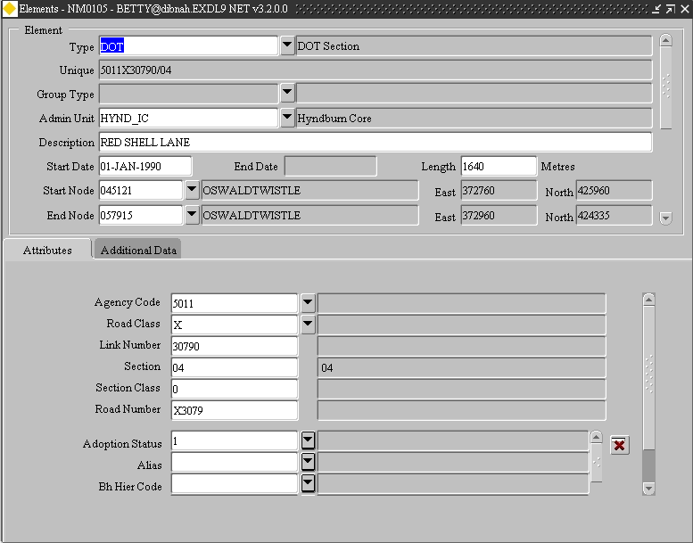

**Network Attributes defined in NM0002**

**‘Primary’ Additional Attributes**

Non Primary Additional Data may be used to associated ‘events’ or other information with a Network Element or Group. For example a ‘Street’ may have many associated ‘Reinstatement’ or ‘Special’ Designations. Each of these ‘event’ Types would be held internally as a different Asset Type and associated with the appropriate Network Type and or Group Type combination. If a Network Type or Group Type is only permitted a single record of a particular Associated Data Type, this may be enforced by checking the ‘Single Row’ check box.

Non-Primary AD is maintained using the ‘Additional Attributes’ Tab on the appropriate Form. An example is shown in

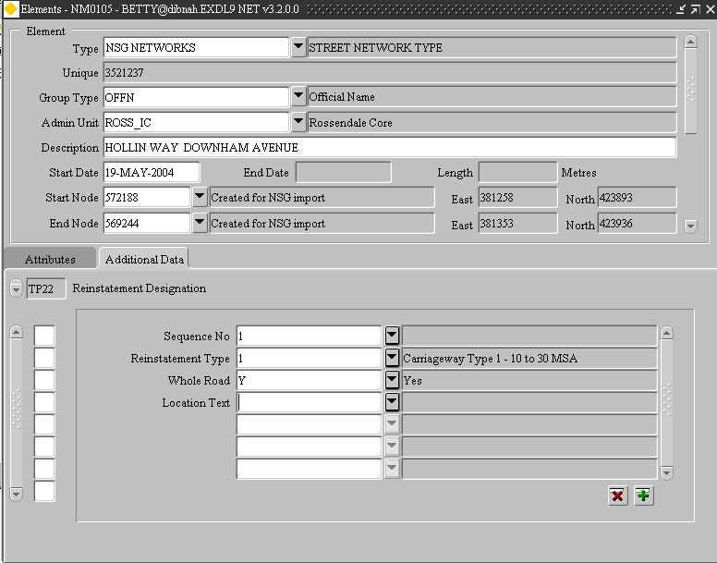Figure 33

Figure 34

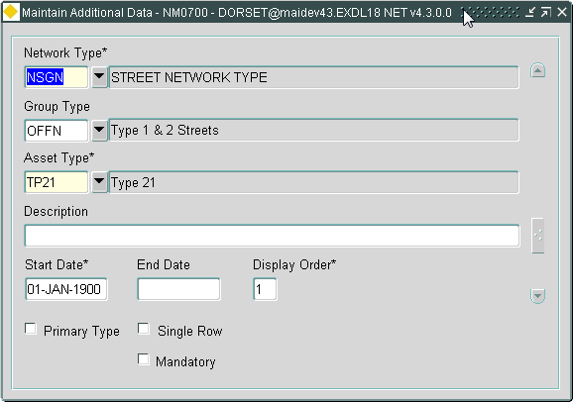**Maintain**

**Additional Data**

Network Type (Required) List

Select the Network Type for which to associate the Additional Data Asset Type

Group Type (Optional) List

Select the Group Type for which to associate the Additional Data Asset Type

Asset Type (Required) List

Select the Asset Type used to ‘hold’ the Associated Data. The list of allowable values will be restricted to those Asset Types of Category ‘***G – Associated Data’***

Description (Required, Default)

A default Description for the Network/Group Type Asset Type Link will be created. This may be amended as required

Start Date (Required)

Enter a Start date for the Asset Type / Network Type Link. AD Items may not be created before this date

End Date

To end date the Link between the Asset Type and the Network/Group Type enter the End Date. No further AD Items of this type may be associated with the Network/Group Type after this date.

Display Order (Required)

If more than one Non-Primary AD Type exists, the display order of Item Types may be determined by entering the appropriate display sequence.

Primary (Checkbox)

If this is the ‘Primary’ AD Type check this box. The ‘Single Row’ and ‘Mandatory’ checkboxes will also be checked by the system and made non –updateable.

Single Row (Checkbox)

This checkbox should be selected if only a single AD Item of this type is allowed. If this is unchecked there is no limit to the number of Items of this type that may be created.

Note that Primary AD Types will always have this option checked.

Mandatory (Checkbox)

This checkbox should be selected if all Network Elements associated with this AD Type must have at least AD item of this type.

Note that Primary AD Types will always have this option checked.

Note: If a ‘Primary’ Additional Data Item Type has been Linked to a Datum Network Type a ‘Datum View’ should be created by pressing the [Create Datum View] button in the Network Types – NM0002 module. The resultant view will join the Network Attributes and the Additional Data Attributes together and may be used as the basis of a GIS Theme.

Network Cross Reference Rules – NM0005

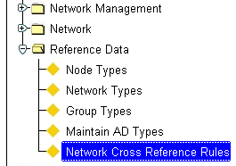Figure 35

Network Cross

Reference Rules

Menu

This form shows the valid relationship between the different ‘Types’ of street within the NSG.

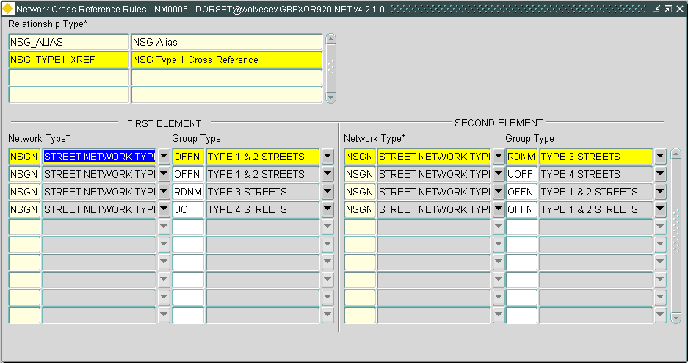Figure 36

**Network Cross**

**Reference Rules**

These rules are where an implicit relationship between streets are not used because of the lack of ‘ESUs’.

Where streets have been defined at ‘Level 1’ (i.e. with no ‘ESUs’), ‘Type’ 3 and 4 streets have to be cross referenced explicitly to ‘Type’ 1 or 2 streets.

These cross references are contained in the ‘Type 12’ records in the NSG files.

The ‘USRN’ field in the ‘Type 12’ record would normally have the ‘Type’ 1 or 2 street and the ‘XREF_ID’ field on the ‘Type 12’ record would have the ‘Type’ 3 or 4 street.

As the data within the NSG files has proven to be a little inconsistent the ‘Network Cross Reference Rules’ allows for the ‘Types’ 1 and 2 streets to be in the ‘XREF_ID’ field and the ‘Types’ 3 and 4 streets to be in the ‘USRN’ field (As shown in ‘FIRST ELEMENT’ and ‘SECOND ELEMENT’).

This module is used and maintained by exor staff and should not be updated without first contacting the exor support staff.

Index

***Additional Data Types*** 39

Asset Type 46

Description 46

Display Order 46

End Date 46

Group Type 46

Mandatory 47

Network Type 46

Primary 47

Single Row 47

Start date 46

Admin Type 15

Autoinclusion

Auto Create 28

Child Column 27

Control Column 28

Parent Column 27

Parent Type 27

Datum 4, 8, 12, 13, 14, 15, 16, 23, 25, 26, 27, 28, 29, 32, 33, 34, 35, 36, 40, 44, 47

***Elements - NM0105*** 13, 17, 23

Flexible Network Attributes

Column Displayed 18

Column Name 18

Column Type 18

Default 21

Domain 18

Format 21

Inherit 22

Mandatory 18

Prompt 18

Query 19

Seperator 22

Seq Name 21

Seq No 18

Str Length 18

String End 22

String Start 22

Unique Format 22

Unique Sequeb 22

Unique Sequence 22

Group Relations

Child Group 43

End Date 43

Start date 43

Group Types

Description 39

End Date 39

Example Group Hierarchy 38

Group relations 43

Group Type 39

Group Types Properties 40

Network Type Groupings 42

Seq 39

Start Date 39

Group Types Properties

Exclusive 40

Icon 41

Linear 40

Mandatory 40

NW Type 40

Partial 40

Reverse Allowed 41

Sub Group Allowed 40

Units 40

National Street Gazetteer 12, 44

NCHRP 12

Network Reference data

Flexible Network Attributes 17

Network Reference Data **3**

Additional Data Types 44, 48

Group Types 37

Network Type 12

Node Types 10

Process Flow 4

Network Type

Autoinclusion 26

Subclass 24

Network Type Groupings

End Date 42

Network Types 42

Start Date 42

Network Types

Admin Type 15

Datum 14

Description 15

Linear 16

Network Type 14

Node Type 15

Pop Unique 16

Unique 14

Unit 16

Product Options **5**

Type Specific Module 30

Type Subclass

Seq 24

Subclass 25